Protected

📌 Definition:
# Source: AI Source: Provided by: [Data Path: Persons Table -> ID Column: 1, Name_En Column: Motasem Essam] -> From: [Chatgpt (GPT‑5 Mini)] on [12/9/2025]
Protected is an access modifier that allows a variable or method to be accessed within the same package and by subclasses (even in different packages).

🧠 Simple idea:
# Source: AI Source: Provided by: [Data Path: Persons Table -> ID Column: 1, Name_En Column: Motasem Essam] -> From: [Chatgpt (GPT‑5 Mini)] on [12/9/2025]
Protected = “Package + Children” 👨‍👩‍👧

🔍 Key characteristics:
# Source: AI Source: Provided by: [Data Path: Persons Table -> ID Column: 1, Name_En Column: Motasem Essam] -> From: [Chatgpt (GPT‑5 Mini)] on [12/9/2025]
- 📦 Accessible within the same package
- 🔗 Accessible by subclasses (even outside the package)
- ❌ Not accessible by unrelated classes outside the package
- 🧩 Useful for inheritance and extensibility

📌 Example (Java):
# Source: AI Source: Provided by: [Data Path: Persons Table -> ID Column: 1, Name_En Column: Motasem Essam] -> From: [Chatgpt (GPT‑5 Mini)] on [12/9/2025]
Parent class:
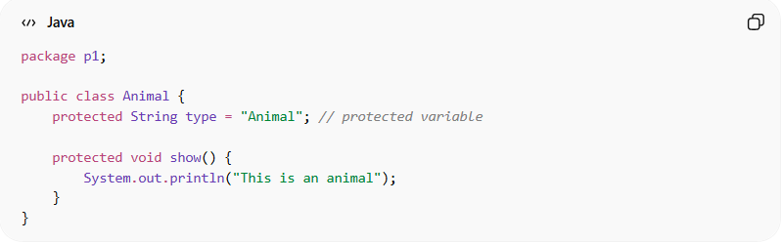
package p1;

public class Animal {
protected String type = "Animal"; // protected variable

protected void show() {
System.out.println("This is an animal");
}
}

Subclass in another package:
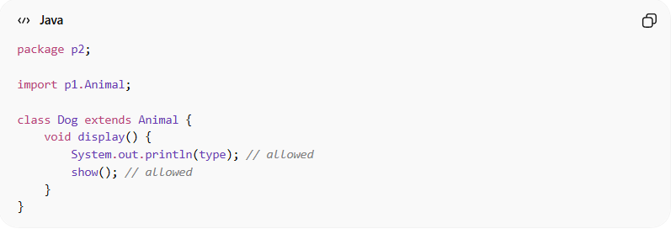
package p2;

import p1.Animal;

class Dog extends Animal {
void display() {
System.out.println(type); // allowed
show(); // allowed
}
}

❌ Non-subclass in another package:
# Source: AI Source: Provided by: [Data Path: Persons Table -> ID Column: 1, Name_En Column: Motasem Essam] -> From: [Chatgpt (GPT‑5 Mini)] on [12/9/2025]
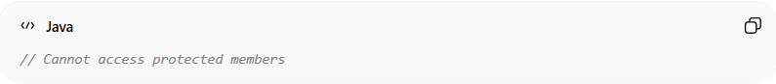
// Cannot access protected members

🔄 Access summary:
# Source: AI Source: Provided by: [Data Path: Persons Table -> ID Column: 1, Name_En Column: Motasem Essam] -> From: [Chatgpt (GPT‑5 Mini)] on [12/9/2025]
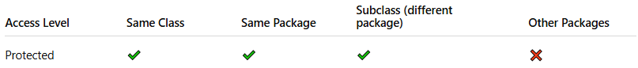
Access Level | Same Class | Same Package | Subclass (different package) | Other Packages
Protected | ✔️ | ✔️ | ✔️ | ❌

🎯 Why protected is important:
# Source: AI Source: Provided by: [Data Path: Persons Table -> ID Column: 1, Name_En Column: Motasem Essam] -> From: [Chatgpt (GPT‑5 Mini)] on [12/9/2025]
- 🔗 Enables controlled inheritance
- 🧩 Shares functionality with subclasses
- ⚙️ Maintains partial encapsulation
- 🧠 Useful in frameworks and base classes

🎯 Summary:
# Source: AI Source: Provided by: [Data Path: Persons Table -> ID Column: 1, Name_En Column: Motasem Essam] -> From: [Chatgpt (GPT‑5 Mini)] on [12/9/2025]
Protected allows access within the same package and to subclasses, making it ideal for controlled inheritance and code reuse.

